**Website User Manual**

Contents

Overview 2

Visitor (Unregistered) 2

To Browse the Product Catalogue 2

Searching 2

Product view 4

Register for Kimi Cosmetic 4

Registered User (Authenticated) 5

Adding items to My Bag 5

Finalising your order 6

Past orders 7

Edit User Profile 8

Change Password 9

User remembers the password 9

User does not remember the password 10

User Account 12

# Overview

This manual is addressed to users who want to run the source code. It gives installation instructions, describes post-installation tasks, and provides information about administration tasks for our website.

Guide to this Document:

The document is organized as follows:

* Visitor (Unregistered)

To Browse the Product Catalogue

Searching

Product view

Register for Kimi Cosmetic

* Registered User (Authenticated)

Adding items to My Bag

Finalising your order

Past orders

* Edit User Profile
* Change Password

User remembers the password

User does not remember the password

* User Account

# Preparing for Installation

A visitor to the site is essentially an unregistered user. A visitor can:

* 1. Browse the Product Catalogue
  2. Register for Kimi Cosmetic

The Kimi Cosmetic home page is shown below.

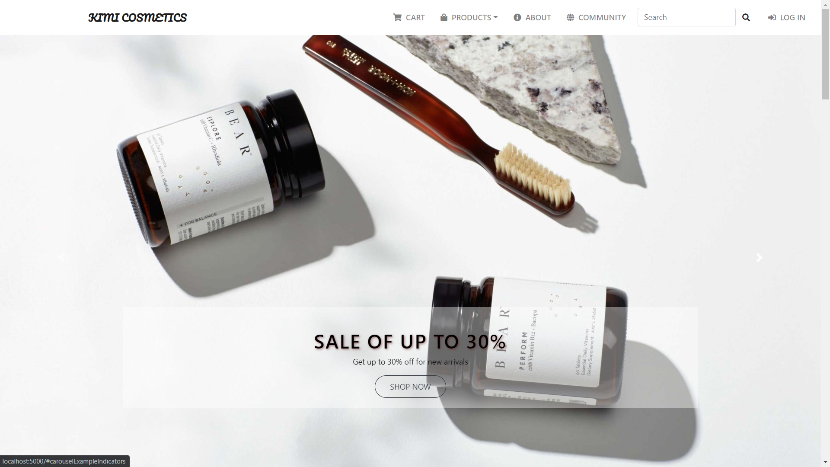

## To Browse the Product Catalogue

### Searching

We offer quick search function and subject categories available to all products and brands

* Quick search:

This is a 'Google' type search using keywords that will retrieve results containing one or more of the keywords you enter into the Search field. For example, a search using the keywords “lotion” will retrieve results containing all three words.

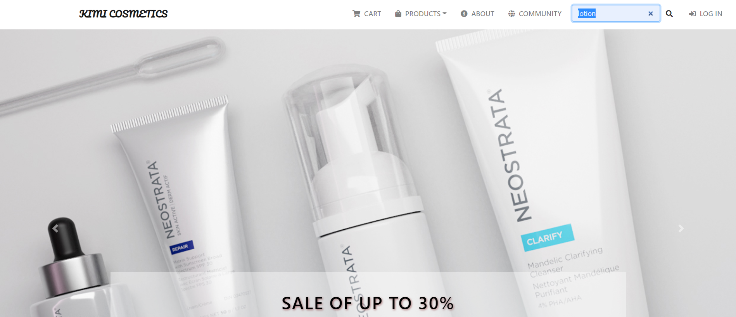

Result:

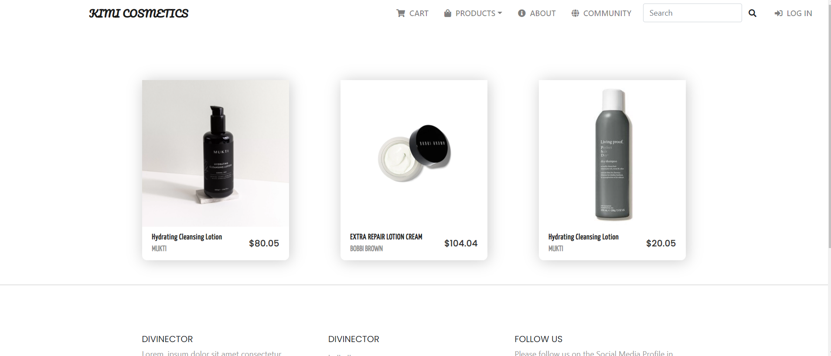

* Subject categories:

Categorie selections pre-created by Bridgeman Education picture researchers

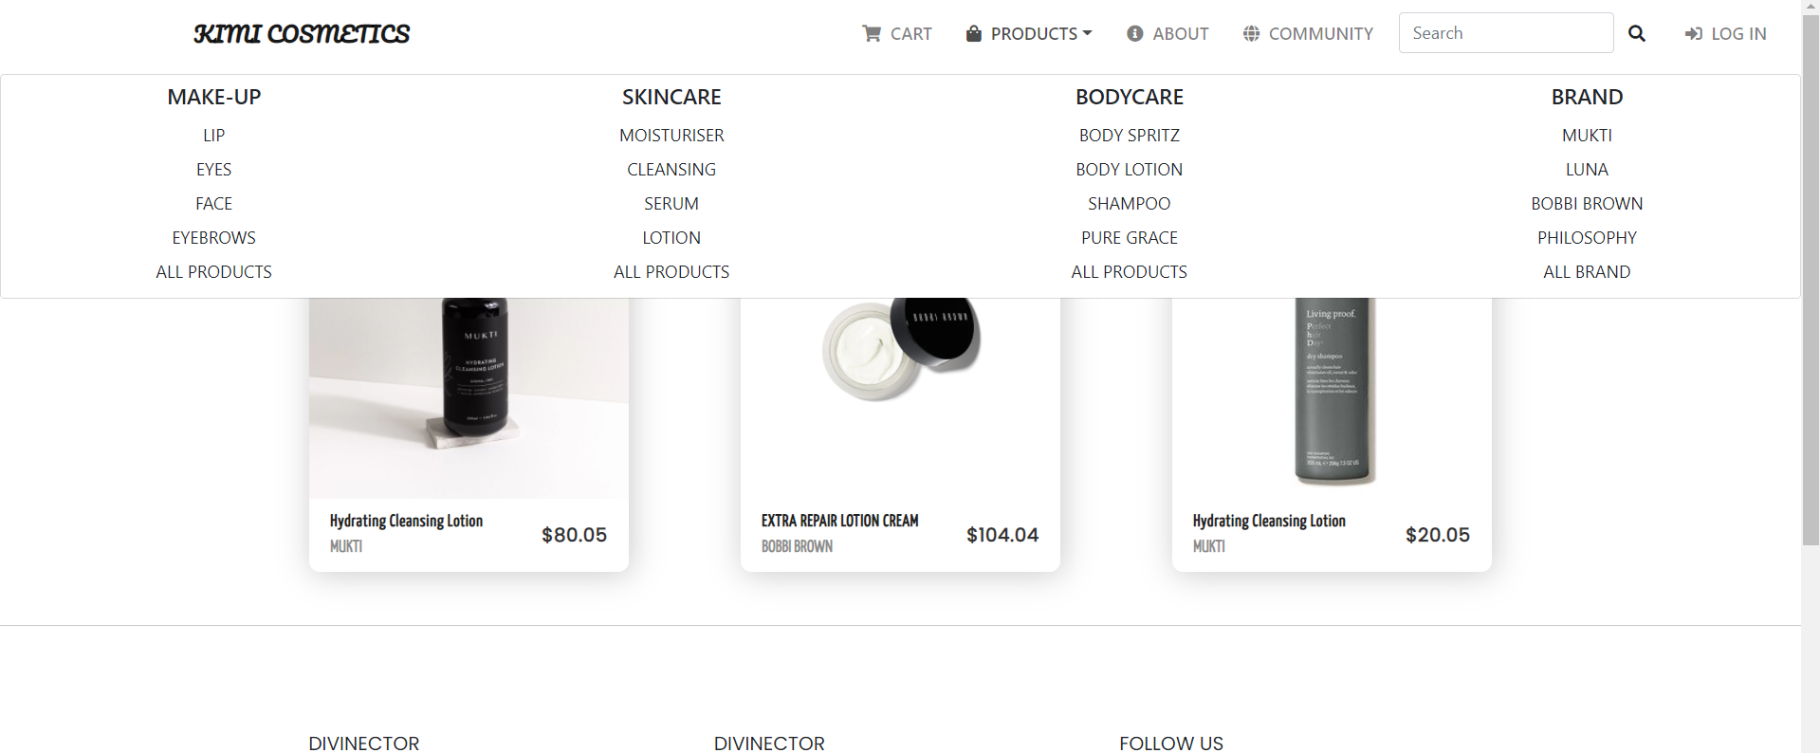

### Product view

* Detailed product information view:

If you want to view more information of product, simply click on ”+”. This will open a new window in which you can see more details of product

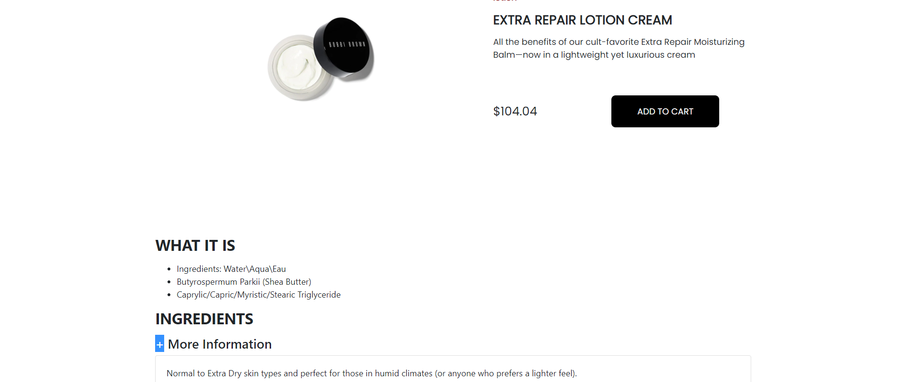

## Register for Kimi Cosmetic

To register for Kimi Cosmetic click the Sign up option.

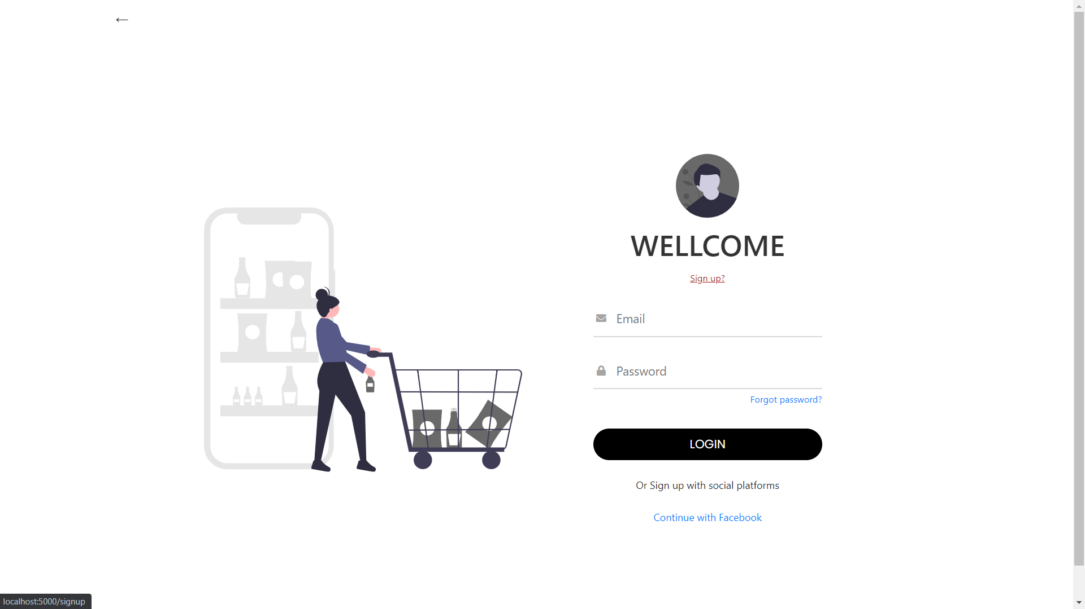

This will take you to the online registration form. Customers are asked to complete this form and click Sign up.

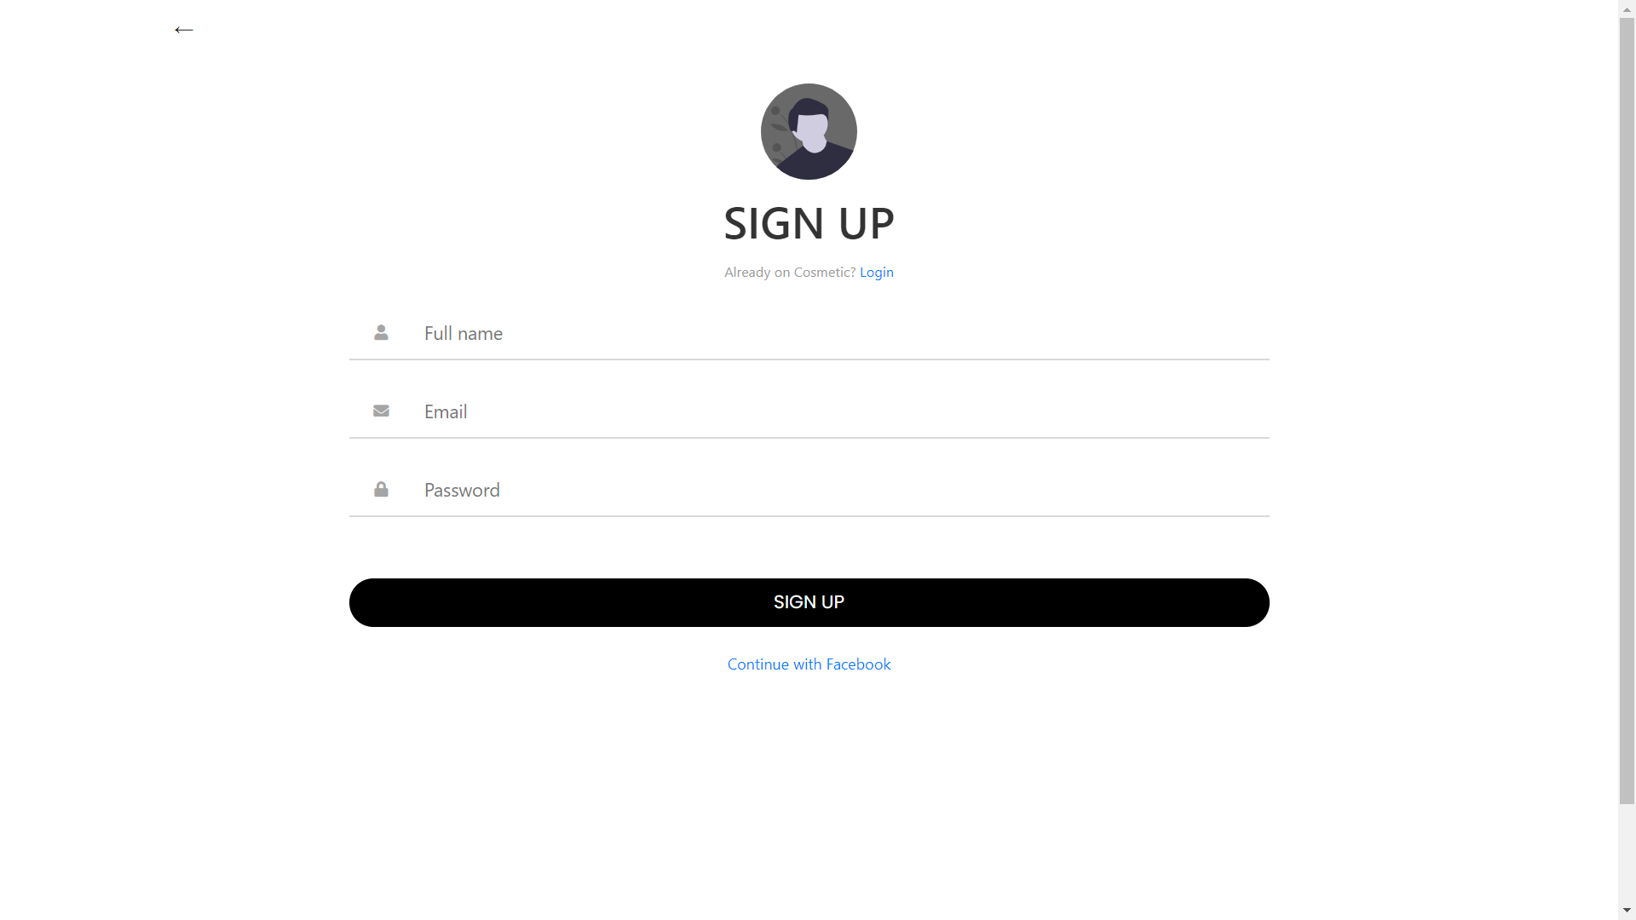

Once the form is received and verified it will be submitted for review and approval. When the application is approved, you will can log in to our website.

# Registered User (Authenticated)

Once you have been validated by the system, you will see a screen as below: 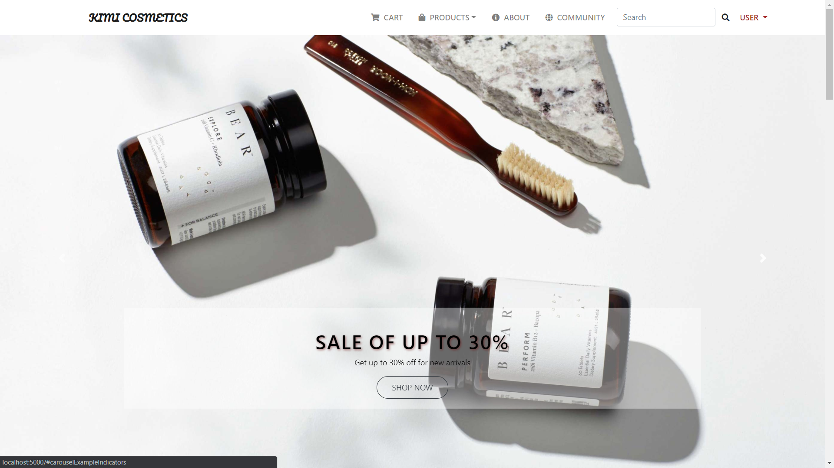

## Adding items to My Bag

This is the most important feature for customers that allows the creation of online orders.

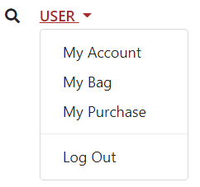

or



Selecting “My Bag” option or “Cart” option in Nav bar will bring you to the following screen:

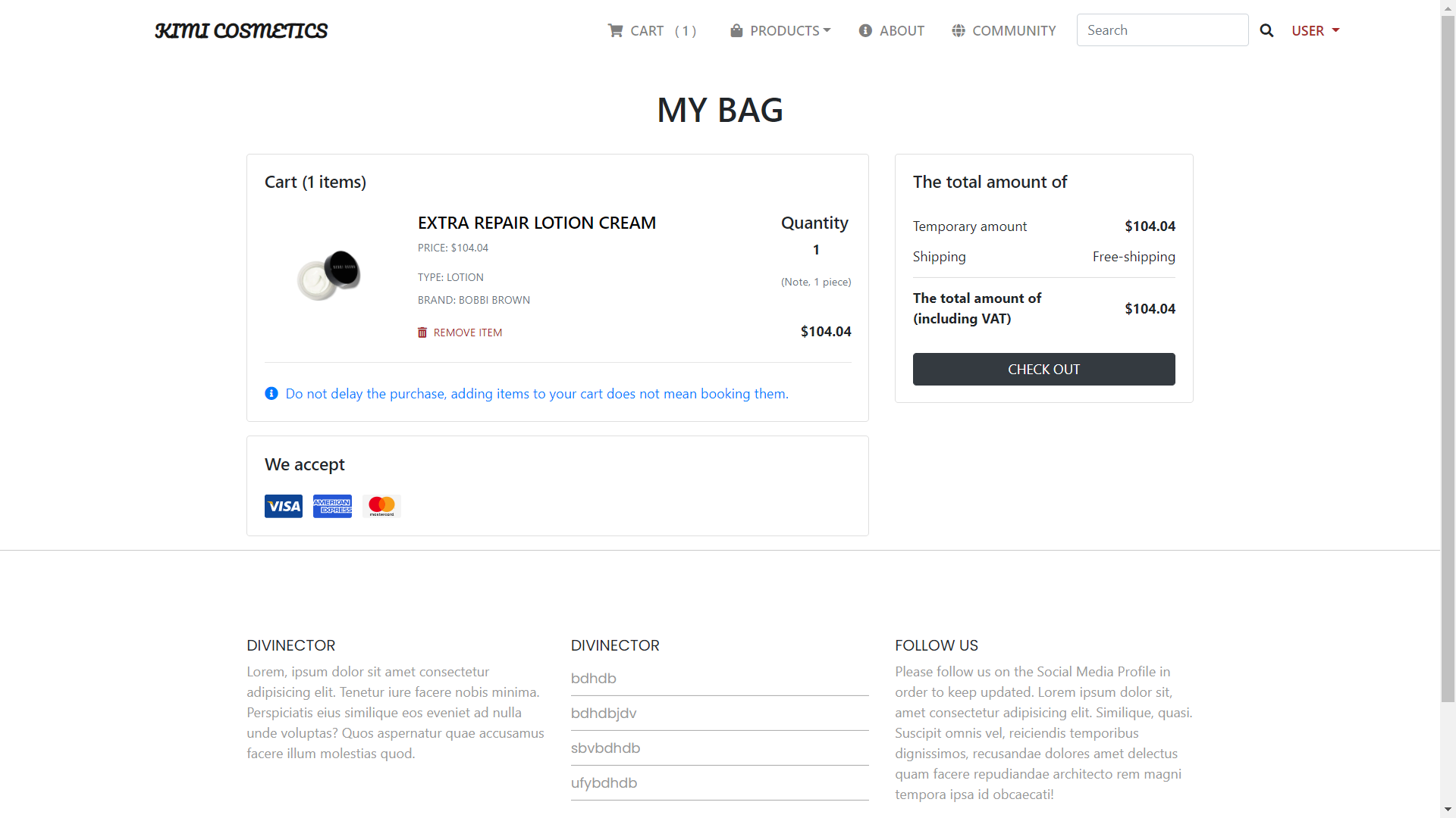

## Finalising your order

To finalise your order, click ‘check out’ button and you will see the following screen:

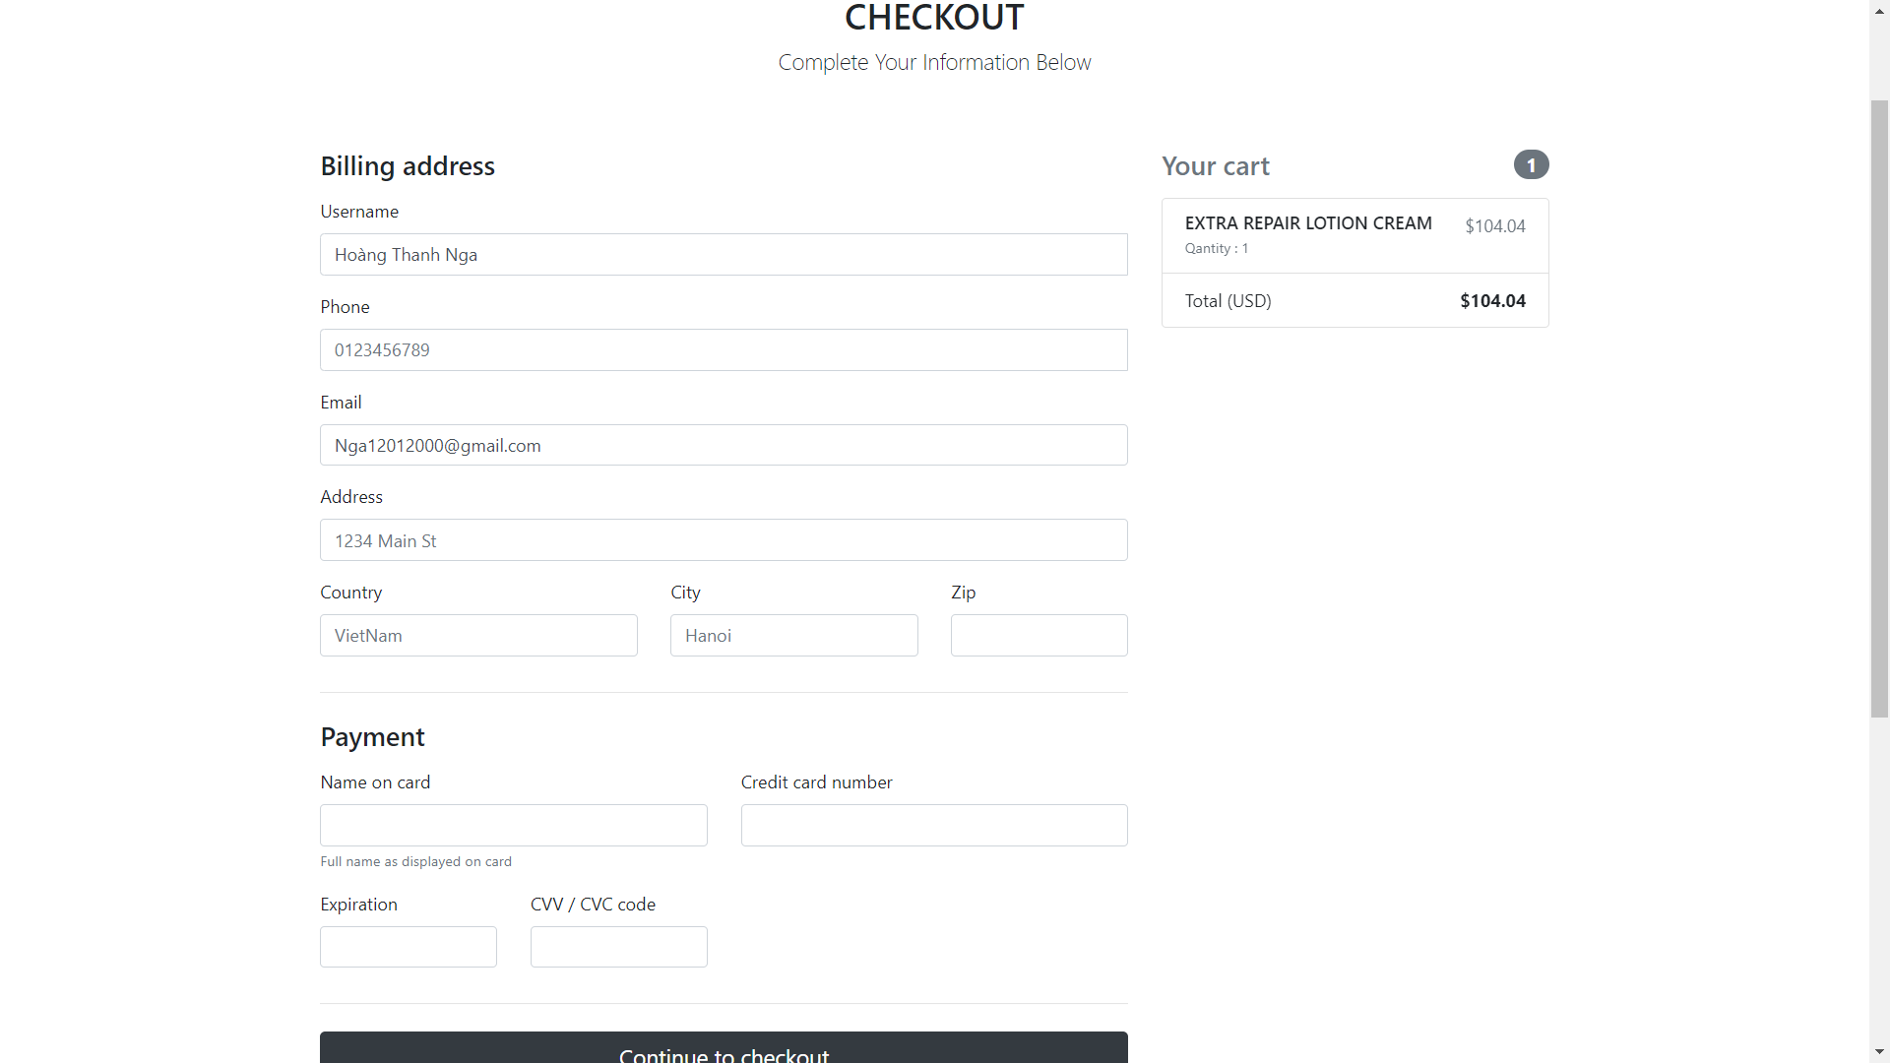

You are required to provide the your correct information for shipping and payment. Once you are happy with your order please click on the “Continue to check out” button.

Your order will be completed and you will view the “My order” screen:

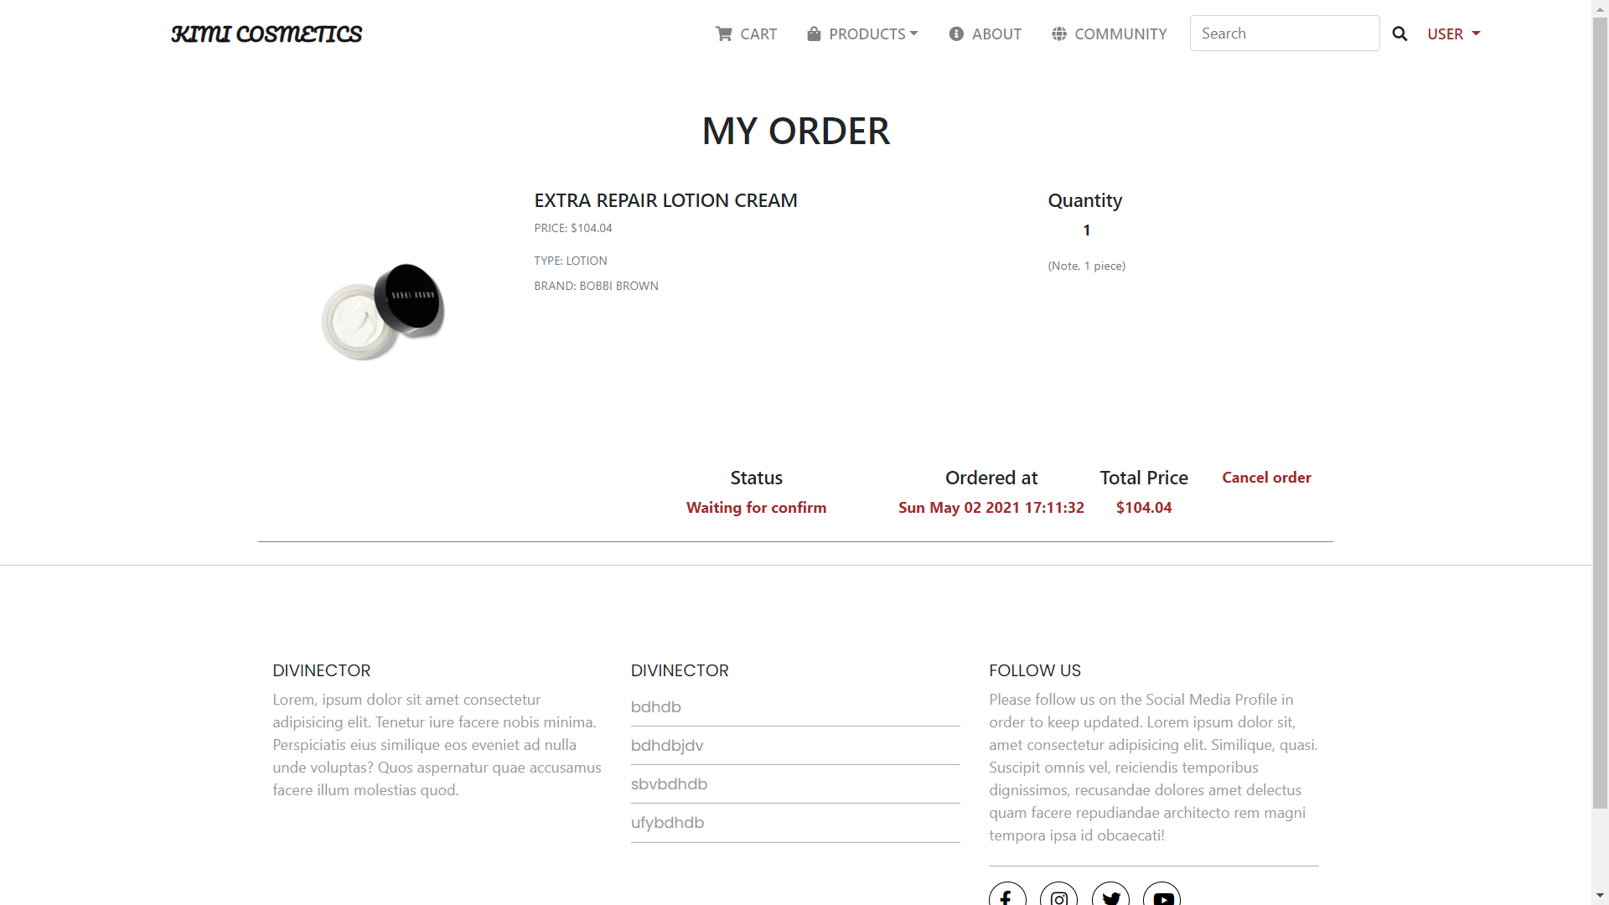

## Past orders

Selecting “My Purchase” option will bring you to the following screen:



You will view your past orders as following screen:

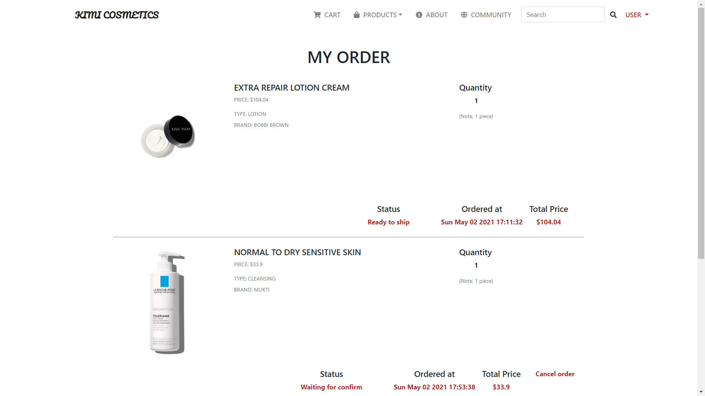

* 1. **Cancel order**

You can cancel order by click “Cancel order” if it’s status is “Waiting for confirm”.



# Edit User Profile

You can edit your Profile by selecting the My Account in the box on the left hand side of the screen



This will display your user details as per below and allow you to make any necessary updates. Once you are happy with your updates, click “Change profile”.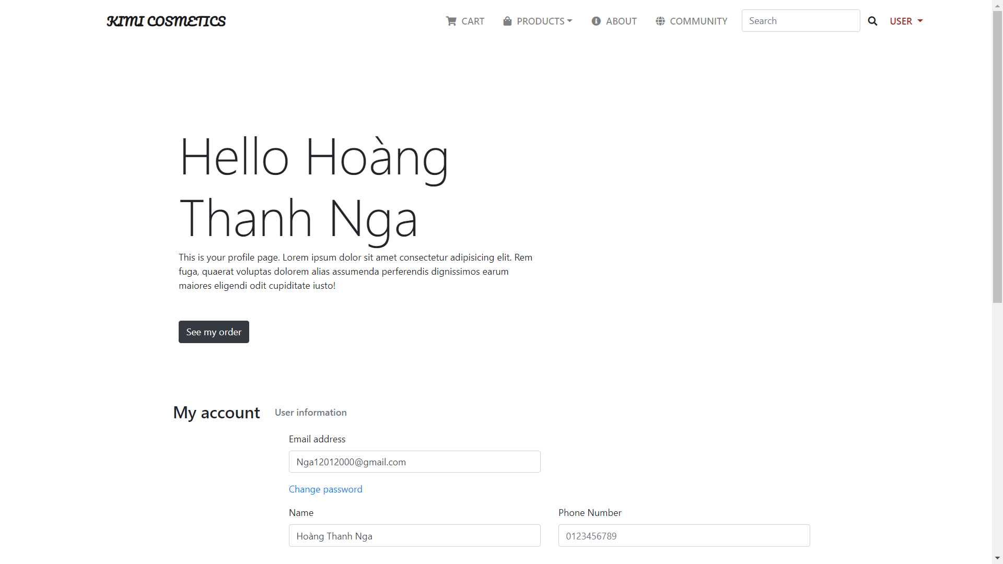

# Change Password

## User remembers the password

To change your password click the My Account button on the box on the left hand side of the screen.



You will see the option with the link here where you can click to update your password

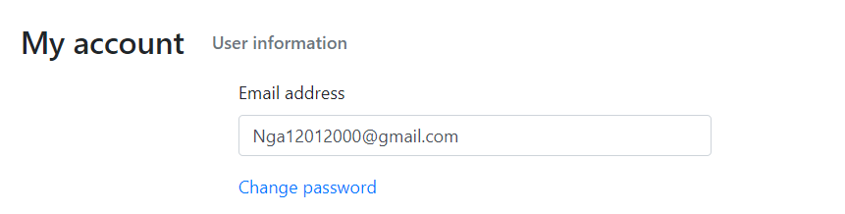

Update your password and click “Change Password” (Your password must have at least 6 characters)

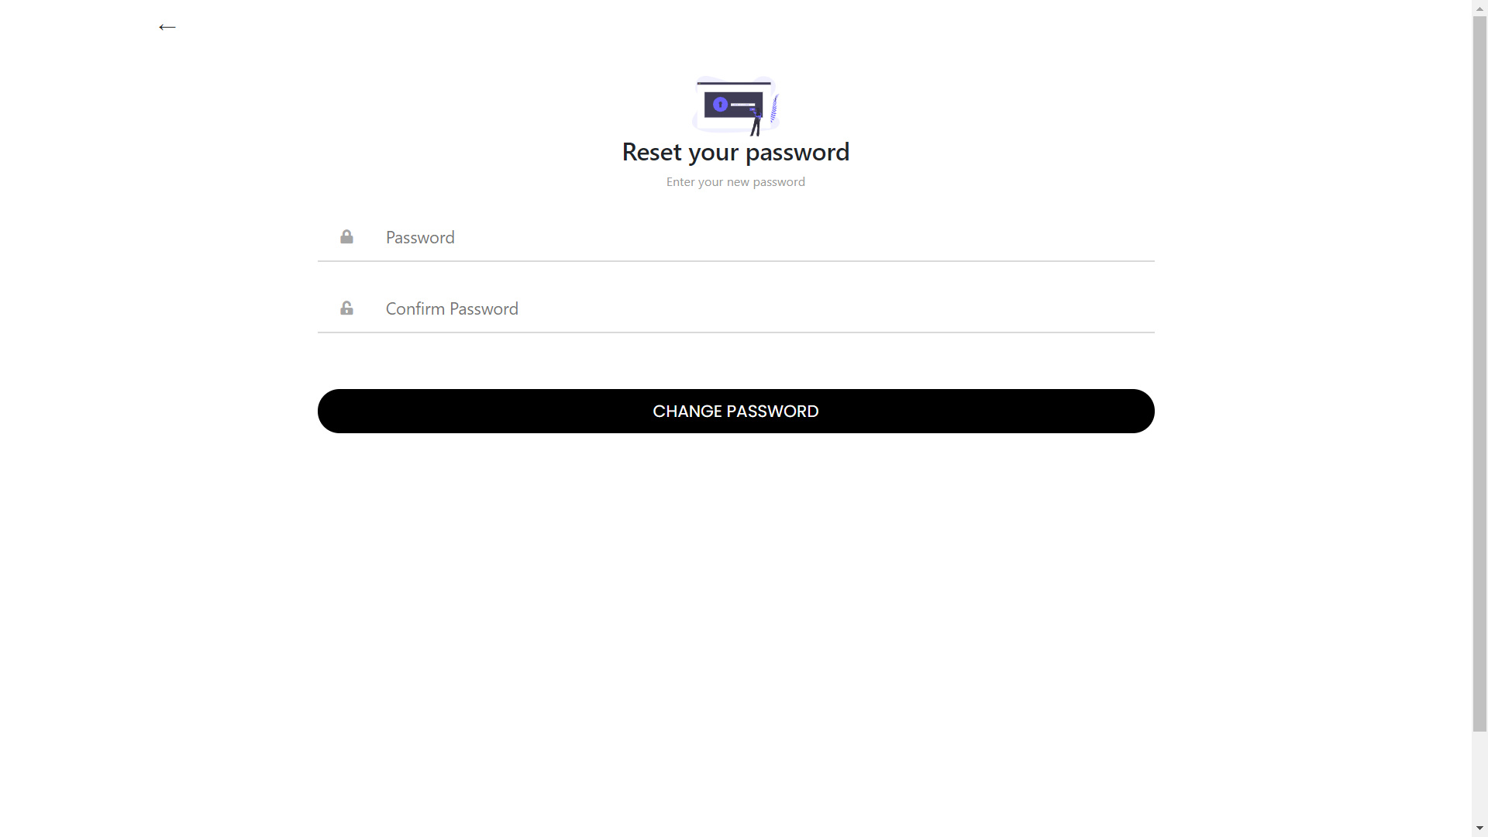

When you submit your updated password you will receive notice of password change from Kimi Cosmetic via email.

## User does not remember the password

In login page, click “forget password” :

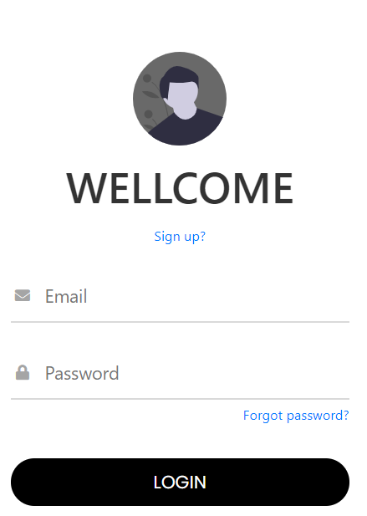

Enter your email that you used to get reset link.

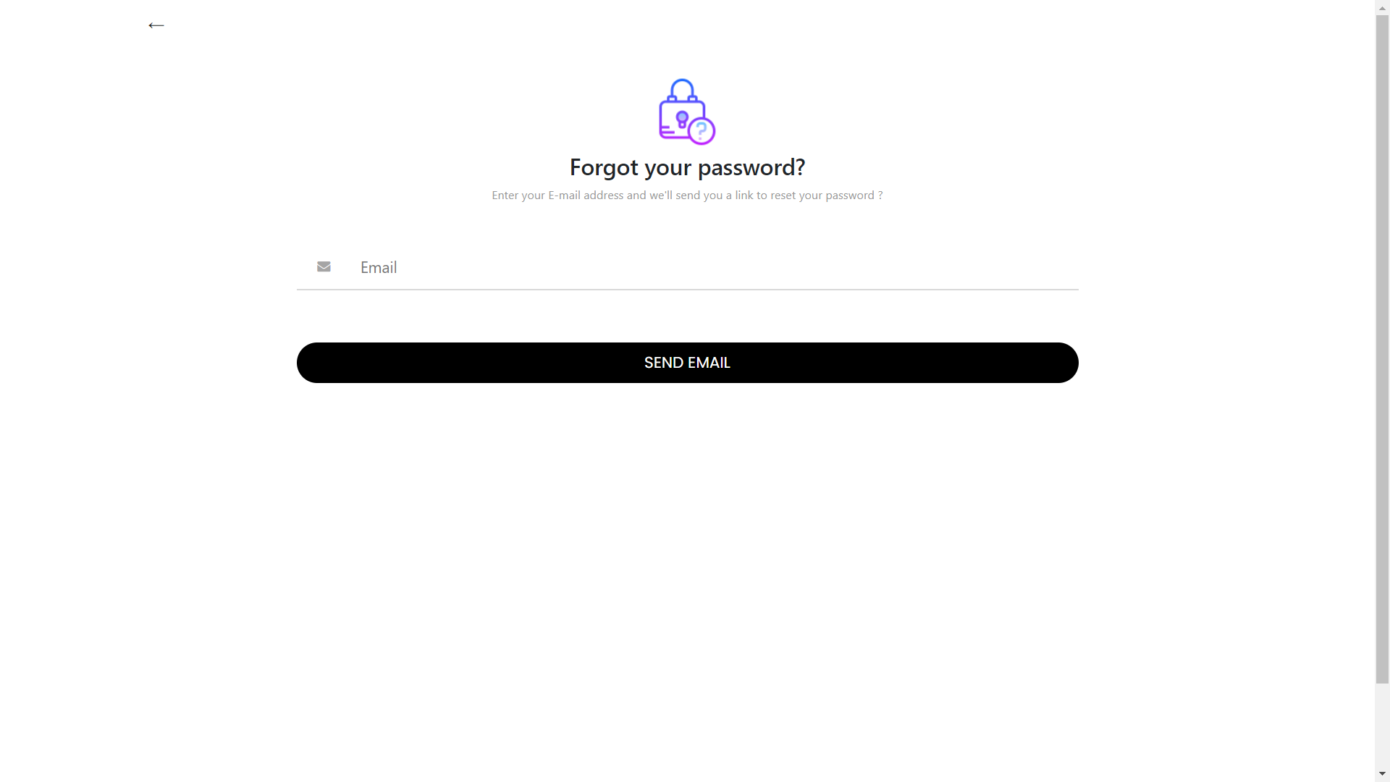

When you send your email, you will see this notice:



Please check your email to get reset password link. You will receive the message like following email:

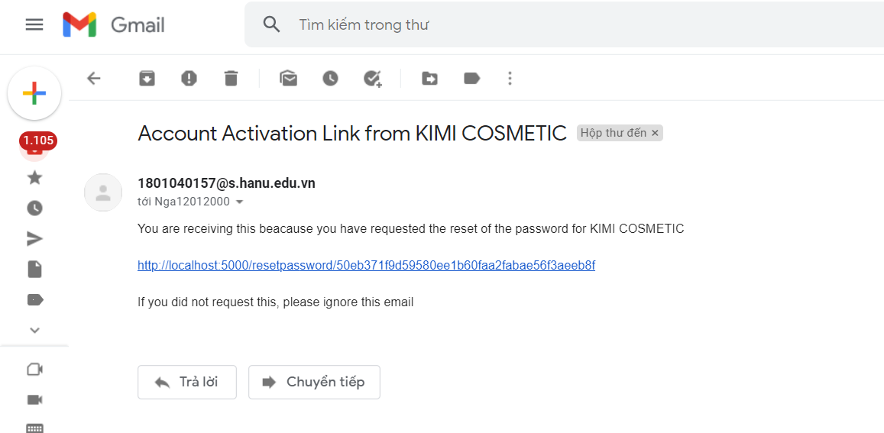

Click the link to get change password form. When you finish update your password, please login again to our website.

# User Account

In order to register for an official account, please fill in the fields with your authentic email

so that the system will be able to reach out using your previously given emaail address

in case we need to contact you when you need to reset your password

your security questions, etc.

Using this sample account to login in case you do not gain any access to the website whatsoever:

username: nga12012000@gmail.com

password: 123456

*ATTENTION* You will not be able to modify/get the reset password link and the password